**Flat Design**

Firebase:

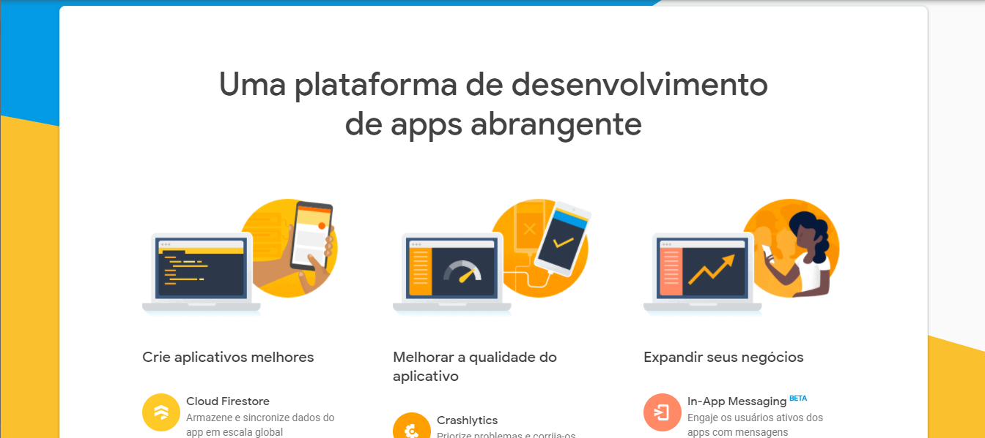

Sea Schedule (app):

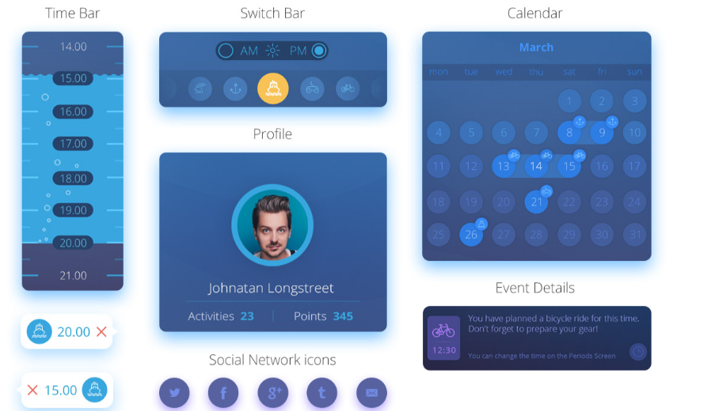

Minimal Monkey:

# 